**Final Analysis**



**PROJECT DETAILS**

Project Name: Comparison and Assessment of Housing and Income Appreciation Over The Past Decade

Team Members: Courtney Gainor, Irwin Bahande Mier, Christopher Reutz, Kim Rones

**RESEARCH QUESTIONS and SUMMARY OF FINDINGS**

1. How have housing prices recovered/increased in relation to the median household income in the US since the Great Recession?  
     
   The Q4 2008 quarter is approximately where housing prices bottomed-out during the last recession. Metros missing data were dropped from the analysis, yielding a sample of 369 (metros metropolitan statistical areas, or MSAs). The scale of each point is based on the metro population size. The gray line shows where income and home value have increased at the same rate (i.e. x=y). **The red regression line shows the fit which nearly follows a one-to-one overall trend with home appreciation slightly more than income appreciation.** The San Diego MSA is noted above in red. It is the nation’s 17th largest metro with a population of 3.3 million. San Diego saw a 10-year growth in home values of 51.3% and median HH income of 25.8%.  
     
   Most metros tended to have greater home vs. income appreciation. **Of the 369 metros, nearly two-thirds (238) experienced home values increasing faster than median HH income.** Home appreciation tended to surpass income appreciation in most of the largest metros. 19 of the largest 25 metros had greater home appreciation, 5 had greater income appreciation, and Washington DC appreciated equally. New York (10.8% v 18.3%), Chicago (1.3% v 18.4%), and Philadelphia (4.9% v 18.3%) were notable exceptions. This tells us that house prices have rebounded faster than the income levels of those who lived in that metro area. This is especially true in 19 of the largest metro areas. If you live in places like San Francisco, Philadelphia, or Dallas, the home prices in your area increased faster than your income.  
     
   We compared the ratio of home value vs. income based on metro size. Only larger metros with a population of 500,000 or more are included - a total of 107 metros. The US average is 1.05, nearly equal appreciation nationally. This is based on the entire population of 933 metros. New York MSA is on the far right with a 20.3 million population and a 0.94 ratio. San Diego MSA - shown in red - ranked 20th across all metros with a 1.20 ratio. This put San Diego in the top quintile for larger metros. Then we did a closer inspection on the value-income ratio by metro area vs their population, but we only analyzed metro areas that had a population of half a million or over. A ratio of over 1 indicates that house price levels have appreciated more than income levels. On the far right you can see the New York MSA with a ratio of 0.94, indicating a ratio of under 1.  
   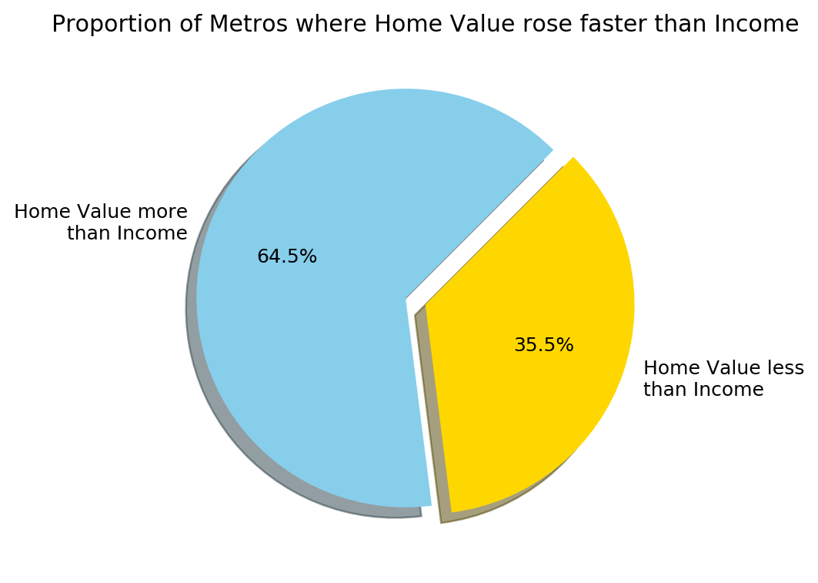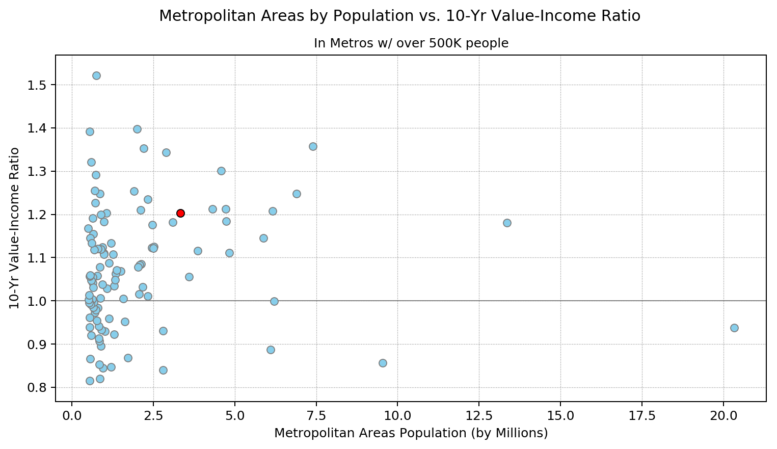
2. How affordable is the San Diego area when compared to other metros across the nation?  
     
   We compared current affordability (Q4 2018) in the largest metros. Affordability is defined as a ratio of current home value over current median HH income. The US average of 3.54 means that home values are 3.54 times greater than annual income. Of the 107 largest metros, San Diego ranked 6th with 7.36. San Jose (10.08), San Francisco (8.94), Los Angeles (8.84), and Honolulu (8.13) were the least affordable. Metro size was a significant factor with Los Angeles (2nd), San Francisco (11th), and San Diego (17th) amongst the most populous metros. We then analyzed the affordability of a current home in the same metro areas. In this case, we defined it as a ratio of current home value over current median household income, and the national average is 3.54. Home values on average are 3.54 times greater than annual income. Looking at San Diego, we can see the it ranks 6th in least affordable housing markets in relation to income. **The size of the metropolitan area was also a factor, as the most expensive metro areas in the nation also happened to be the largest.**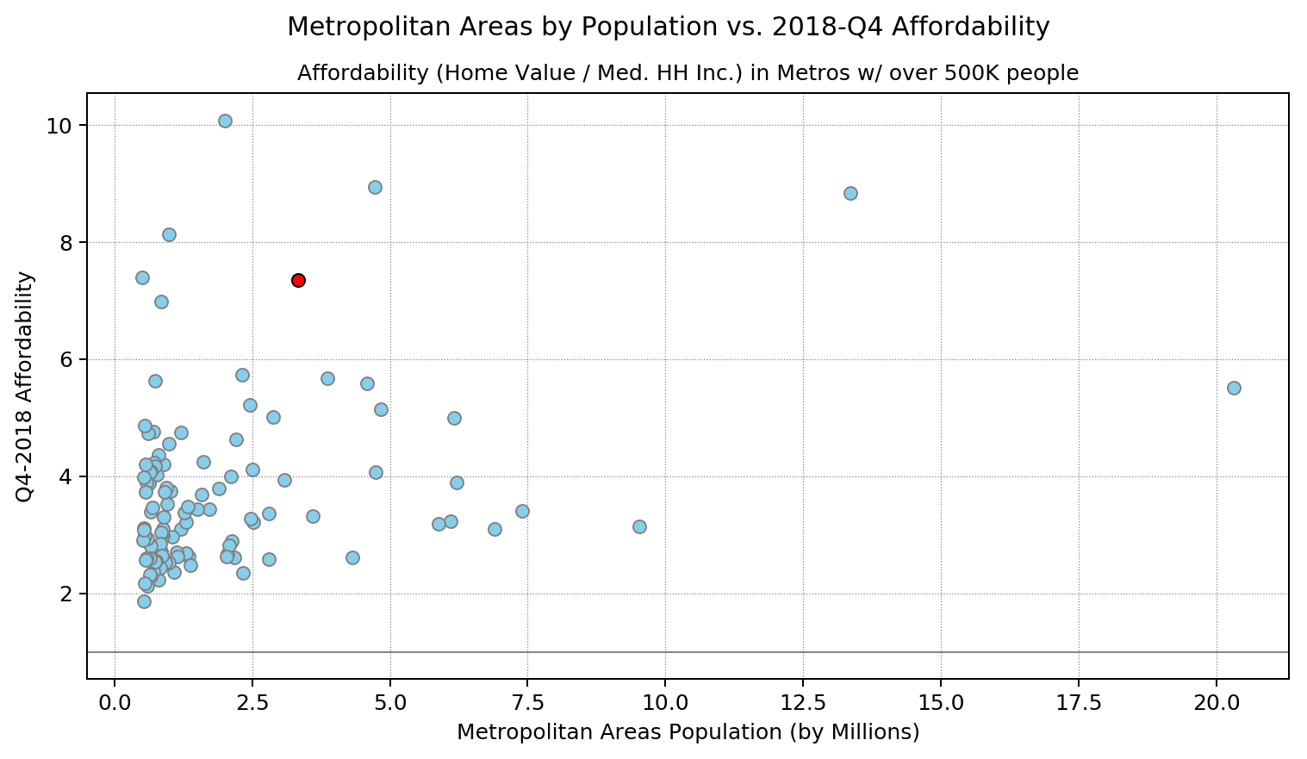
3. In which San Diego County zip code areas would it be best to invest in a single-family home?  
   We looked at data for the time directly following the Great Recession up until now, as home prices took a huge dip at that time. When points are below 100, the median home value that month was less than what it was in June 2009, such as around the dip, and when the points are above 100, there is recovery from the low values during the Great Recession. **The Barrio Logan/Logan Heights area (the top blue line) was the zip code that appreciated the most, which this graph clearly shows.**  
     
   Then, we decided to take those top 10 appreciating zip codes, and take a look at how the actual median home values fluctuated over time. Encinitas housing prices (the top green line) are higher than the rest of the top 10 zip codes causing it to be an outlier. Even though 92113 (Barrio Logan / Logan Heights / South East San Diego area) is the lowest line (the blue one) on the graph, it still had the highest appreciation rate. **Based on this representation of the data, it appears that 92113 is currently the best market to invest in a single-family home in San Diego County.** It has the highest appreciation rate, meaning that the value of the homes in this area increase on average at a faster rate than homes in other areas of SD County. In addition to this, it is also the area with the lowest cost of housing (when looking at these top 10 appreciation rates) meaning that it is a great market that is also easy to get into. Since these are the top 10 highest appreciating zip codes, any of them would be great areas to look into purchasing residential property, but as you can see here, where you are able to look may be determined by how much you are willing to spend.  
     
   We compared the median home values of the most and least appreciated zip codes in SD with the averages for SD County and CA. Here, we decided to make maximum use of the data that was available from Zillow, to see if we could notice any other trends. We included data going all the way back to 1996, so that we could have a broader perspective on how median home values fluctuate before, during, and after the Great Recession. The gray section in the center represents the Great Recession, which lasted from Dec 2007 - June 2009. It took a couple of years to recover after the recession as home prices continued to dip until 2011. While the lines all seem to follow similar trends of dropping and recovering, we can make more conclusions by looking at this graph. It appears that our highest and lowest appreciating zip codes in San Diego County both had median home values that were consistently less than the averages for the county and state. Our highest appreciating zip code actually started off with lower home values than the lowest appreciating area, but climbed much higher, especially in recent years. During the Great Recession, the home values of the two were very close, even overlapping for a brief stint. But while Barrio Logan/ South Eastern San Diego (92113), the green line here, had the highest appreciation value, progressing from a median value of 163,000 to a median value of 404,000 with an appreciation rate of 134.58%, Borrego Springs had the lowest appreciation value in SD, barely appreciating at all at a 2.7% appreciation rate. Fun fact: the second lowest appreciating zip code was 92067, Rancho Santa Fe, with median home values consistently higher than 2 million. **This representation of the data shows us that median home value does not necessarily determine the rate of appreciation.** While 92113 appears to be the best current single-family home investment due to its very high appreciation rate since the Great Recession, and it’s relatively low median home value (less than that of the county and state), there are other variables that may factor into how attractive a particular market may be.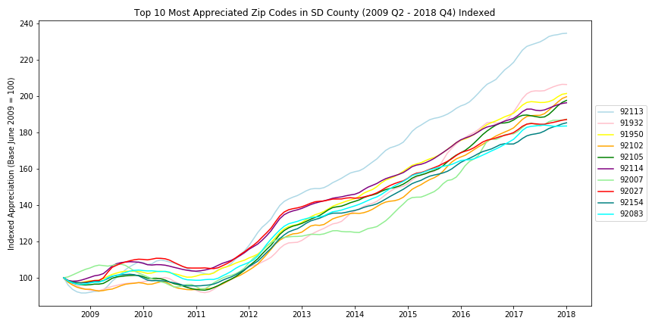
4. Opportunities for future analysis  
   Our project first focused on determining a good investment based on a comparison of Median Household Income, Median Home Value, and Population Size on the metro level. Once zoning in to our county and using zip codes for zoning, we then used only Median Home Value over time as our variable to determine our pick for best investment. Similar projects could be done with a plethora of other factors, which we expect would correlate with the data we have found so far. Some opportunities for future analysis in the realm of our project include: Ranking school district test scores/performance, Number of parks, Low crime rate, Proximity to natural landmarks (beach/mountains/lakes).